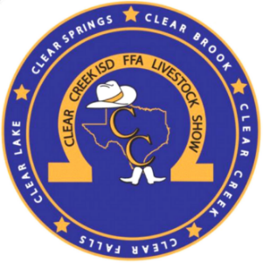
Clear Creek ISD Livestock Show & Auction Book
Advertising Order Form 2023-2024

Thank you for your support!

Advertiser Name: The way you want it to appear in the Index of the Guide

Company Name or Individual Name (if different from advertiser name):
__________________________________________________________________________________________________________
Street Address: ____________________________________________________ City: ___________________ State: ____________
Email Address: ___________________________________________ Phone Number: _____________________________________
Quantity | Advertisement Size (see back page for size illustrations) | B/W | COLOR | $ AMOUNT
 | Business Card – please include hard copy (do not staple) | $40 | N/A
 | Quarter Page | $60 | N/A
 | Half Page | $80 | N/A
 | Full Page | $100 | $200
 | Cover – Inside Front  email rwalton@ccisd.net for availability | N/A | $400
 | Cover – Outside Back  email rwalton@ccisd.net for availability | N/A | $600
 | Cover – Inside Back  email rwalton@ccisd.net for availability | N/A | $400
 | Copy of Livestock Show & Auction Book - $10  Available to pick up at the Auction on January 18, 2024. | N/A | N/A
Payment Info | Cash Check #: _____________  (Make payable to Clear Brook FFA. You can mail a check with this completed form to the address below.) | Total Payment Amount:  $ _______________

All ads must be uploaded using the online form by Wednesday November 29, 2023.
You may attach a hard copy to this form, but the quality of the final product may not look as professional.
Digital Form & Upload Ad
Scan the QR code to complete the online order form and submit your files.
Supported file formats are PDF and JPG.
Online payments unavailable.
https://forms.gle/TtsBgegGznQXirLHA
The Clear Creek ISD Livestock Show & Auction Book will be distributed at no cost to registered buyers at the Auction on January 18, 2024. The Book will contain information about the CCISD FFA Chapters and the CCISD Livestock Show & Auction, and the printed advertisements purchased through this sale! Copies of the book are also available for purchase using this form. The Show & Auction Book and Advertisement Sales are a fundraiser for the Clear Brook FFA Chapter and is ran by its members.

Media Release: I hereby give Clear Brook FFA and its representatives permission to print, and distribute my photos, logo, and any
media submitted to our publication.
Quarter Page
Business Card
Full Page/Cover
[Size illustrations are not exact but to give an approximate representation of size.]
Half Page

