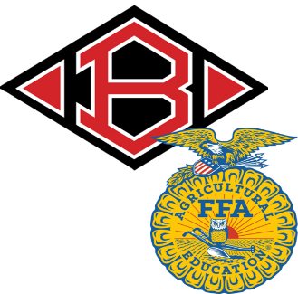
Clear Brook FFA Membership Form 18-19
Please return this form to an Ag teacher by October 2nd. The information below is needed for your FFA registration. FFA dues are $30.00 and can be paid in cash or money order. You will receive ONE t-shirt with your paid dues that will be delivered at a later time.
Student Name: ____________________________________________________ Grade: __________________
Address: __________________________________________________________________________________
Phone #: _________________________________ Email: ___________________________________________
Parent/Guardian Name(s): _______________________________ ,____________________________________
Phone #1: _________________________________ Phone #2: _______________________________________
Email #1: _________________________________ Email #2: _______________________________________
T-shirt size for included t-shirt: S M L XL 2XL
Student Information
Ag Classes enrolled in: _______________________________________ Years in FFA: __________________
Are you interested in raising an animal in the future? Yes No
Species: ________________________ Show: CCISD PLSR GCFR Majors
Are you interested in joining LDE or CDE’s? Yes No
Team/Contest: _______________________________________________________________________
Other FFA activities are you interested in (ex: calf scramble, speaking contests, talent, etc.):
_________________________________________________________________________________________
Do you give Clear Brook FFA permission to put your (student)
picture on the CBFFA Website/Facebook/Instagram/Twitter? Yes No

Communication Authorization
CCISD policy allows only a teacher, trainer, or other employee who acts as a coach or sponsor of a sport or extracurricular activity to use text messaging to communicate with students/athletes who participate in the activity. By signing this authorization, you are granting permission to the coach/sponsor to call or text important information to you and/or your student at the number you provide on this form. Text messaging may be used only as necessary and only to communicate information directly related to the sport/extracurricular activity. Concerns about any inappropriate communication by any CCISD employee should be reported to the campus principal.
I, ____________________________________, agree that an authorized coach/sponsor (Ms. Nosrat, Mr.
(Parent/Guardian)
Cranfill, and/or Ms. Lamb) may contact my student by cell phone to communicate important team, group and/or practice information on an “as needed” basis.
Student Name: _____________________________________________________________________________
- Appropriate phone number(s) for communication: ___________________________________________
Parent Signature: _______________________________________________ Date: ___________________
FFA Member & Parent Expectations
1. Communication with teachers: teachers may be contacted by phone Monday-Friday from 6:30 am – 6:30 pm. Any other hours please email questions and/or concerns, unless there is an emergency or previous permission has been given. Be polite and respectful in all communications. Please contact a veterinarian for animal emergencies.
2. Communication with other students/parents: treat others how you would like to be treated. If you have an issue with another student or parent please address it with an ag teacher. Be polite and respectful in all communications.
3. Behavior at FFA functions: be dressed appropriately for the event. Be polite and respectful to everyone present.
4. Calendar: it is the students/parents responsibility to keep up with chapter activities by either checking the online calendar, the calendars in the classrooms, or by checking in with the teachers/officers on a regular basis.
I understand the expectations listed and as a Clear Brook FFA member/parent I agree to follow them.
Parent Signature _________________________________________________ Date:__________________
Student Signature ________________________________________________ Date:__________________

